Additional Exercises 8



The assignment A1 with A1(a) = 1, A1(b) = 0, A1(c) = 0 is a model.



The assignment A1 with A1(a) = 0, A1(b) = 1, A1(c) = 1 is a model.



|  |  |  |  |  |  |
| --- | --- | --- | --- | --- | --- |
| A | B | ᆨB | A ∧ B | A → ᆨB | (A ∧ B) ∧ (A → ᆨB) |
| 0 | 0 | 1 | 0 | 1 | 0 |
| 0 | 1 | 0 | 0 | 1 | 0 |
| 1 | 0 | 1 | 0 | 1 | 0 |
| 1 | 1 | 0 | 1 | 0 | 0 |

There are no assignments A1 that are models, therefore A1 is unsatisfiable.



|  |  |  |  |  |  |
| --- | --- | --- | --- | --- | --- |
| A | B | ᆨA | ᆨB | (ᆨA ⋀ ᆨB ) | (ᆨA ⋀ ᆨB) → (ᆨA ⋀ ᆨB ) |
| 1 | 1 | 0 | 0 | 0 | 1 |
| 1 | 0 | 0 | 1 | 0 | 1 |
| 0 | 1 | 1 | 0 | 0 | 1 |
| 0 | 0 | 1 | 1 | 1 | 1 |

There is an assignment for A1 that is a model, therefore A1 is satisfiable.





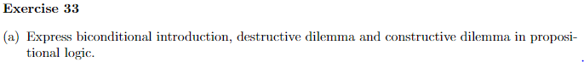







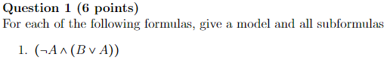

The assignment A1 with A1(A) = 0, A1(B) = 1 is a model.

Subformulas:

A

ᆨA

B

(B V A)

(ᆨA ∧ (B V A))



The assignment A1 with A1(A) = 1, A1(B) = 1 is a model.

Subfo



≡